TITLE OF THE PAPER

Don't use the superscript if all authors come from the same organisation/institute

François MERSENNE1, Herman Von HELMHOLTZ2,   
Joseph-Louis LAGRANGE1, Lord RAYLEIGH3

1 CETIAT, Aeroacoustic Department, 25 avenue des Arts, B.P. 2042,   
69100 Villeurbanne cedex, France

2 CETIM, 52, avenue Félix-Louat, BP 80064. 60300 Senlis, France

3 Technische Universität Darmstadt, Karolinenplatz 5, 64289 Darmstadt, Germany

# SUMMARY

The purpose of this brief summary is to explain in a few words, the topic of the paper to give additional information that the title cannot. This part should **not** exceed 8 lines in the present A4 format. This section should not just copy the submitted abstract as this is likely to exceed the word limit. Aligned right and left, the margins are increased by 1 cm in left and right side.

# introduction

**All detailed information about the formalism of the draft/final paper is available at the end of this document, from page 3 and 4.**

The International Conference on Fans will be held in Antibes Juan-les-Pins, France, 9- 11 April 2025.

Besides all the papers, the Fan 2025 Proceedings will be based on web browser technology, which avoids any software installation. It will offer a search engine that facilitates the retrieval of papers based on keyword(s), author or session.

Each participant of the Fan 2025 will receive a booklet of abstracts on paper format.

# General rules

The paper is to be written in **English** and its size **must** **between 6 to 9 pages (strictly) in length, including** annexes, diagrams, graphs, charts and images, **excluding** references, bibliography and acknowledgments. The papers which do not respect this rule and the following instruction may be rejected**.**

Every paper will be reviewed by the Scientific Advisory Committee and may be rejected if it doesn’t comply with the scientific/technical level of the meeting or if it requires significant reworking. Authors will have 4 weeks approximately to make the corrections required by the reviewers. Therefore, it is the author's responsibility to proof-read his paper carefully before submission.

# how to use this template effectively

The formatting rules requested for the congress are applied in this template, or even start from your draft and do "copy/paste without formatting" in the template, for example for titles, paragraphs, captions.

The rules for a paper formatted according to the present rules are explained in the following pages. To simplify matters, it is highly recommended to use the current file as a basis for your paper, so that you don't worry about the margins etc.

You just have to "save this file as" and type its name (preferably the reference number of the paper + your name, e.g. **038_carolus.docx**.

As all sections are correctly formatted, you should "copy and paste" the necessary elements (tables, legends, titles, etc.) replacing the text given in this template with your text.   
**For detailed instructions of paper formatting please, see pages 4 ⇨ 6.**

# What to send?

The Fan 2025 uses an extranet (powered by Oxford Abstracts) for the authors, with 3 steps:

* Abstract submission, with a short review … already and successfully done if you are reading this document,
* Draft paper submission, with a review by the Scientific Advisory Committee members (the present stage for you),
* Final paper submission   
  *Note:* *Inclusion of your paper in the proceedings will only be possible* ***if the speaker is******registered*** *– to be done* ***before 14 February 2025***

## Draft Paper

For the review process, the authors must send their draft paper, written using the present template, in **pdf format**, before **Monday 24 Nov. 2024.**

## Final paper

Because the papers will be published in digital form on a CD, the authors have to produce their papers in electronic format.

All figures must be incorporated into the document.

Before **Monday 14 February 2025** (and not after), you are required to upload

* the **pdf file of your final paper**

AND

* the **Microsoft Word format** (preferably Microsoft WORD, or OPEN OFFICE saved in the Microsoft format) of the same final paper.

If the **abstract** previously sent through the Extranet has been deeply changed, you are allowed to update this abstract (min 200 words - max 400 words), again using Extranet.

# ° ° ° ° ° ° ° ° ° ° ° °

# GENERAL PREFERENCES

**The paper must be between 6 and 9 pages, including** annexes, diagrams, graphs, charts and images, **excluding** references, bibliography and acknowledgments**.**

The typing space per page is 160 mm wide and 245 mm high. The resulting margins are:

* A4 format → top 25 mm, others 20 mm, (left, right, bottom)

The font in the paper is MS Word "Times New Roman" or "Times", 12 pt, color black, justified.

Paragraphs are single-spaced, and a **6 pt spacing** is required **after each paragraph**. No indent at the beginning of sections.

# AUTHORS

The authors of the paper are mentioned in the right order (not alphabetical order).   
Only the last name is presented in UPPER CASE, but not the first name.

If the authors come from different firms, a superscript number is added after the name, and the list of firms is given below (see example above):

François BESSAC1, Geoff SHEARD2, Thomas CAROLUS1

1 CETIAT, Acoustic Department, 25 avenue des Arts, B.P. 2042,   
69100 Villeurbanne cedex, FRANCE

2 CETIM, 52, Avenue Félix-Louat, BP 80067  
60304 - Senlis Cedex, FRANCE

Do not use superscript if all authors belong to the same company / university.

# TITLES (capital - 15 pt regular)

## Sub-titles (12 pt bold)

Titles and sub-titles are not numbered and should written according the following examples.

Titles correspond to Title 1 style ⇨ [Ctrl Shift 1]. → Spacing: 12 pt before and 12 pt after

Sub-titles correspond to Title 2 style ⇨ [Ctrl Shift 1]. → Spacing: 12 pt before and 6 pt after

## Language

The language of the paper is English, and the preferred spellings are British English.

Papers should be written in the third person in an objective, formal and impersonal style.

## Units

SI units should be used wherever possible

## Pictures, graphs

The pictures, graphs, schemes should be centered in the text.

The legend is placed below the picture/graph, centered, in italics, 10 pt. The object and its legend should both be on the same page and not span a page break.

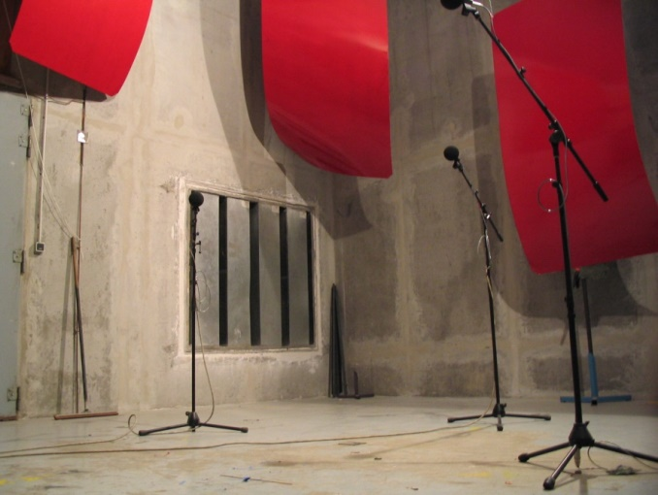

*Figure 1: reverberant room*

## Tables

The tables should be centered in the text. The text uses Times New Roman font. The table caption is inserted before the table, in 10 pt, italics.

*Table 1: sound power level of tested fans*

|  |  |  |
| --- | --- | --- |
|  | **Lw - dB** | **LwA - dB(A)** |
| **Fan 1** | 46.0 | 43.7 |
| **Fan 2** | 48.4 | 45.6 |

## Equations

The equations should be centered in the text, and if required, with a number right aligned. The tabulation tools can be helpful here.

 (1)

The size of the main font is 12 pt, and the font is always Times New Roman.

# BIBLIOGRAPHY

The reference section is placed at the end of the document, except if there are also appendices.

The references should be numbered and typed in consistent formalism, including at least, name of authors, title (italics), the source, and the year (bold) at the end.

[1] J. E. Ffowcs Williams, D. L. Hawkings – *Sound generation by turbulence and surfaces in arbitrary motion*. Phil. Trans. Ryo. Soc., A264, **1969**

[2] ISO 5136 – *Acoustics - Determination of sound power radiated into a duct by fans and other air-moving devices - In-duct method*, **2003**

[3] A. Guédel, Y. Rozenberg, M. Roger, G. Perrin – *Prediction of fan trailing-edge noise* Proceedings of Fan Noise 2007 Symposium, Lyon, **2007**

# ANNEXES / APPENDIXES

If you have annexes, they are placed at the end of the document.

The length of the document is strictly from 6 to 9 pages **including appendixes**. Only **references**, **bibliography** and **acknowledgments** can cause the document to exceed 9 pages.